August 10th, 2008
Hi
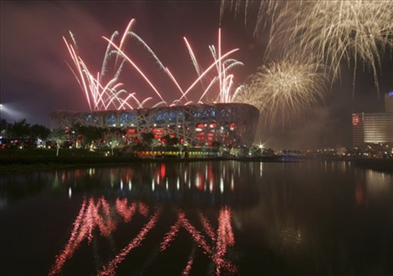
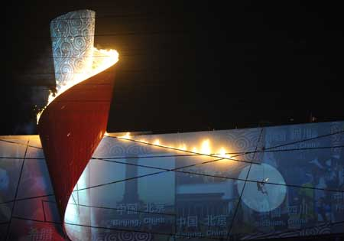
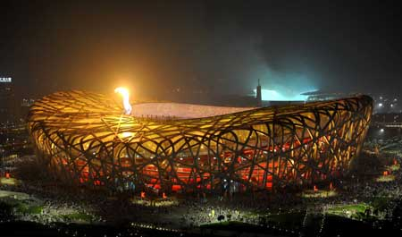
Of course, the big news of the past week was the opening of the Olympic Games in Beijing and the Equestrian events here in HK. I watched the 4⁺ hour opening ceremony. It was really spectacular, absolutely stunning. Near the beginning video was shown on the large stadium screens showing the ancient Chinese method of paper making. This was followed by the unrolling of a large, thick (2 cm) paper scroll which covered much of the inner area of the track and on which many of the opening performances were held. The show lasted about 70 minutes. More than 15000 people involved and some of the shows used exactly 2008 performers. Then there was the entry of the athletes. Countries entered not according to alphabetical listing in English but according to the numbers of strokes in the Chinese characters for the names. Thus Australia, which is usually one of the first to enter, was this time one of the last. After the oath taking, the Olympic flame was lit. Spectacular! A former Chinese top gymnast was chosen for this task. Attached to wires, he soared through the air taking large ‘steps’ towards the flame. He then lit a fuse (about 20 metres long and 10 cm thick which ignited the flame – middle photo).

Now that the opening is over, I will not watch much of the games themselves. Most Olympics (and particularly this one) seem to be as much about nationalism as about sport, that is, how many medals can ‘our’ country get and can we get more than ‘your’ country can? If people were really interested in the sports, attendance at events such as as athletics and swimming outside of the games would be better attended (though sports such as basketball, soccer and tennis are popular and do seem to be followed for the sports themselves). In addition, there is always the doubt in the minds of many people whether of not medal winners are on drugs or not. I will probably watch the closing event, which will also probably be spectacular.

The Equestrian events commenced on Saturday. To avoid the worst of the heat and humidity, events are being held earlier in the morning and later in the afternoon. Quite a number of the spectators left the proceedings long before they ended saying they had no idea what the events were all about. The organisers must have anticipated this as they were broadcasting comments about the events to the spectators. There have also been a number of protests in HK about Tibet and/or human rights in China. One protestor scaled a tower of the Tsing-Ma suspension bridge and unfurled a banner. Several locals disrupted Equestrian events before they were evicted. In HK, large screens have been set up in Victoria Park and Shatin Park to provide coverage of the games free for the public to watch.
Other things, of course, also took place during the week. On Monday, I began exercise again following my back injury though after exercise, I realise that it is not completely healed. Monday included a swim. And would you believe it, just as I was about to get into the water, a (brief) thunderstorm began, after not having had any while I was out of action! Did some laps until the pool was evacuated then did the rest after a short break.

On Tuesday, the #3 storm signal was hoisted. This was upgraded to #8 early on Wednesday morning and in place for most of the day. Consequently, most of HK was shut down (as happens when #8 signal or higher are up). It caused little damage to the facilities at the equestrian venues.
Finished reading the sci-fi novel I mentioned last week. Actually became very good once the main theme and the subsidiary theme (initially boring) combined. This book is the second in a four-part series. I want to read the remaining books. However, Book 3 is not in any HK public libraries while Book 4 is, though not in the local library. However, I have requested it, which is possible for a fee of just HK$2.50. In the meantime, I found 'Treasure Island.' in my own bookshelves and am reading that. It was one of about five books I bought from a bookshop sale in Christchurch the last time I was there.
There were no Tri-nations games this weekend. There was a test between SA and Argentina, which the Springboks won 63-9.
That seems to be about it for now.

Cheers

